Look What We Did!!  Thank You  I want to express my sincere gratitude to those who donated their time or and or money on Wednesday, November 22,2023. Thank you to your contribution to The Friendsgiving I was able to prepare over 30 meals to 50 Thornton Women’s Shelter as well as 37, & 45 South Ferry street. We were so blessed that we even had meals to give out to those who were in need of a meal in the Albany Community.  Because of You  Because of you, we was able to share the legacy and be a part of what Father Young has created. Just this act of kindness touched so many in ways we may not understand. In addition, this is what the Peter Young Foundation is all about, and I am more than delighted to be a part of this foundation.  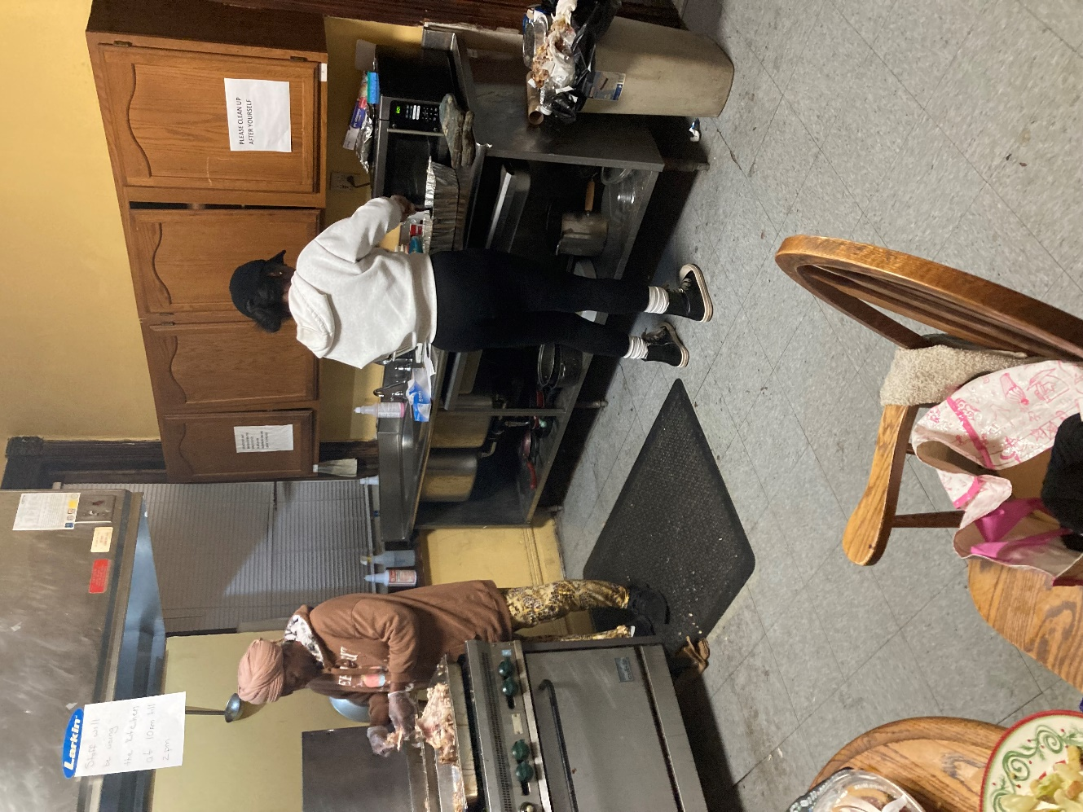 |  | Thank you ALL for making Our Friendsgiving possible.
 |  |  |  | 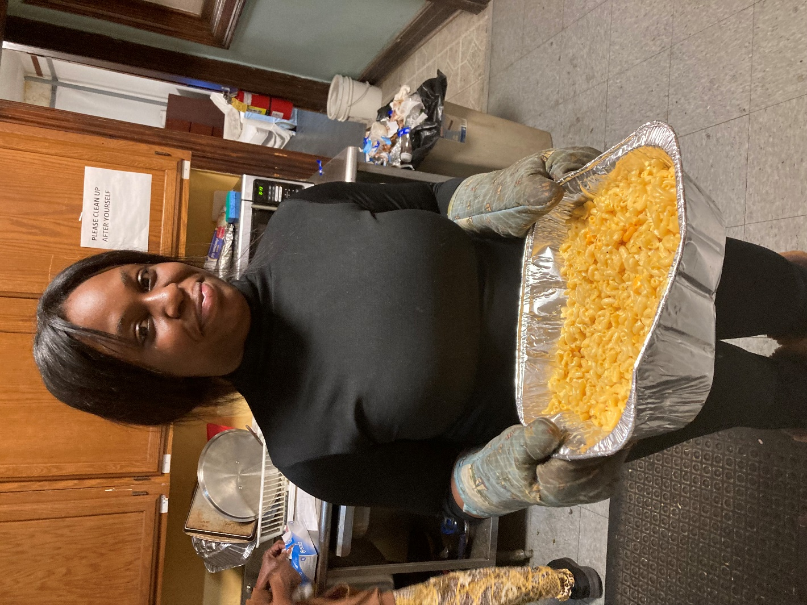

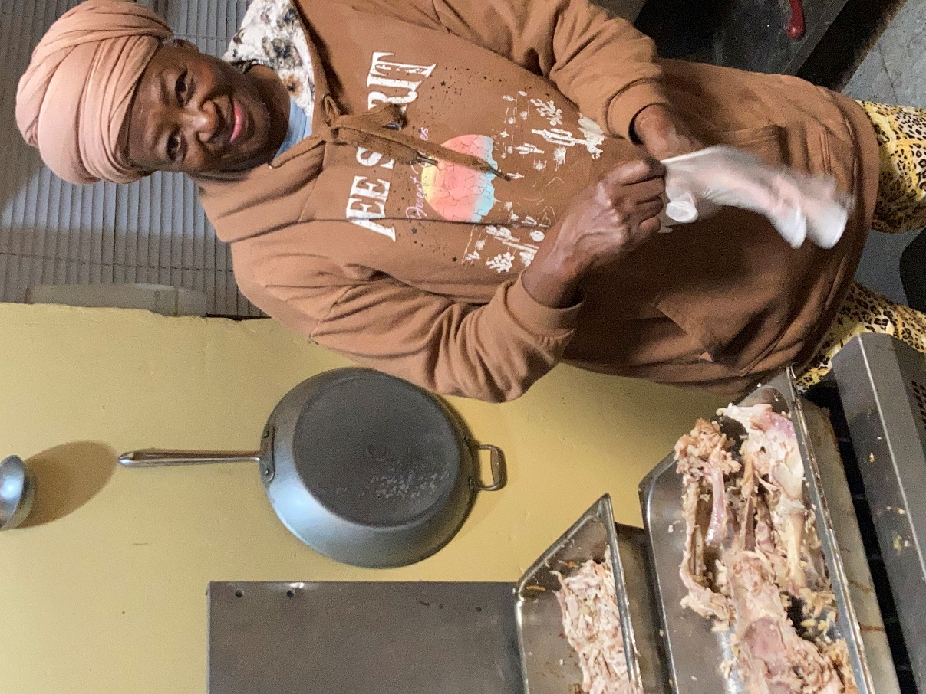 |  | Act of Kindness  Your generosity is what gives these people hope. Hope in knowing that there is someone out there who cares.  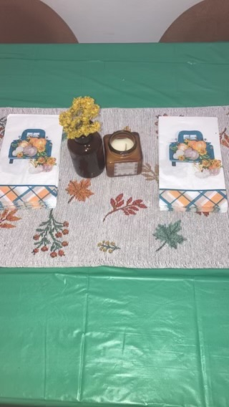 |  | 